**Applying linear relationships**

**In-class investigation Solutions and marking key**

**Question 1**

|  |  |  |  |  |  |  |  |  |  |  |  |  |  |  |  |  |  |  |  |  |  |  |  |  |  |  |  |  |  |  |  |
| --- | --- | --- | --- | --- | --- | --- | --- | --- | --- | --- | --- | --- | --- | --- | --- | --- | --- | --- | --- | --- | --- | --- | --- | --- | --- | --- | --- | --- | --- | --- | --- |
| (a) Solution  **Total payments**   |  |  |  |  |  |  | | --- | --- | --- | --- | --- | --- | |  | Number of hours | | | | | | Plan | 2 | 3 | 4 | 5 | 6 | | A | $40 | $60 | $80 | $100 | $120 | | B | $46 | $64 | $82 | $100 | $118 | | C | $47 | $63 | $79 | $95 | $111 | | |
| Marking key/mathematical behaviours | Marks |
| * Calculates total payments for each of the three options * Accuracy throughout | 3  1 |

**Question 1**

|  |  |  |  |
| --- | --- | --- | --- |
|  | Solution | Marking key/mathematical behaviours | Marks |
| (b) | The hourly rate is constant  The payments increase by a constant amount as the hours increase by 1 | * Refers to hourly rate in first table * Refers to increase in second table | 1  1 |

**Question 2**

|  |  |  |  |
| --- | --- | --- | --- |
|  | Solution | Marking key/mathematical behaviours | Marks |
| (a)  (b)  (c) |  | * Uses variables provided * Formats rule correctly * Identifies hourly rate for all tables * Identifies constants in all tables | 1  1  2  2 |

**Question 3**

|  |  |  |  |
| --- | --- | --- | --- |
|  | Solution | Marking key/mathematical behaviours | Marks |
| (a) | |  |  |  |  | | --- | --- | --- | --- | |  | Number of hours of child minding | | | | Plan | 2 | 4 | 5 | | D | $60 | $120 | $150 | | E | $60 | $110 | $135 | | F | $60 | $100 | $120 | | * Reads payment for 2 hrs * Reads payment for 4 hrs * Reads payment for 5 hrs | 1  1  1 |
| (b) | (i) 0 (ii) 10 (iii) 20 | * Reads y-intercept | 3 |
| (c) | D has the steepest line | * Links gradient to rate | 1 |
| (d) | Intersect at the same point | * Identifies intersection as point of equality | 1 |

**Question 4**

|  |  |  |  |
| --- | --- | --- | --- |
|  | Solution | Marking key/mathematical behaviours | Marks |
| (a) | $20 | * Use data from various sources to identify largest value | 1 |
| (b) | 0 | * Use data from various sources to identify least value | 1 |
| (c) | $30 | * Use data from various sources to identify largest value | 1 |
| (d) | $15 | * Use data from various sources to identify least value | 1 |

**Question 5**

|  |  |  |  |
| --- | --- | --- | --- |
|  | Solution | Marking key/mathematical behaviours | Marks |
|  | (i) W and Y  (ii) Z  (iii) Y  (iv) X and Z  (v) A (and D) | * Identifies same gradient * Identifies lack linearity * Reads graph to determine value * Read graph to determine values * Identifies 0 as vertical intercept | 1  1  1  2  2 |

**Question 6**

|  |  |  |  |
| --- | --- | --- | --- |
|  | Solution | Marking key/mathematical behaviours | Marks |
| (a) | |  |  | | --- | --- | | Rule to calculate  payment | Payment for 5 hours work | | *K*=10*r* + 10 | $60 | | *K*=15*r* + 10 | $85 | | *K*=20*r* + 25 | $125 | | *K*=25*r* + 30 | $155 | | * Uses variables given * Identifies constant * Identifies hourly rate * Presents formula correctly * Uses formulae to determines payments * Presents values with $ | 1  1  1  1  1  1 |
| (c) | Joel $170  Billy $30  Brooke $130 | * Uses correct rule from table * Uses correct rule from table * Uses correct rule from table | 1  1  1 |
| (d) | Billy: Total of 7 hours on 3 different nights = $100  Brooke: 3 nights of 4 hours = $390  Joel does 6 nights, each of 3 hours = $510 | * Total adds to $1000 * Indicates number of petrol allowances * Indicates number of hours * Correct scheduling for each person | 1  1  1  1 |

**Question 6 (b)**

Solution

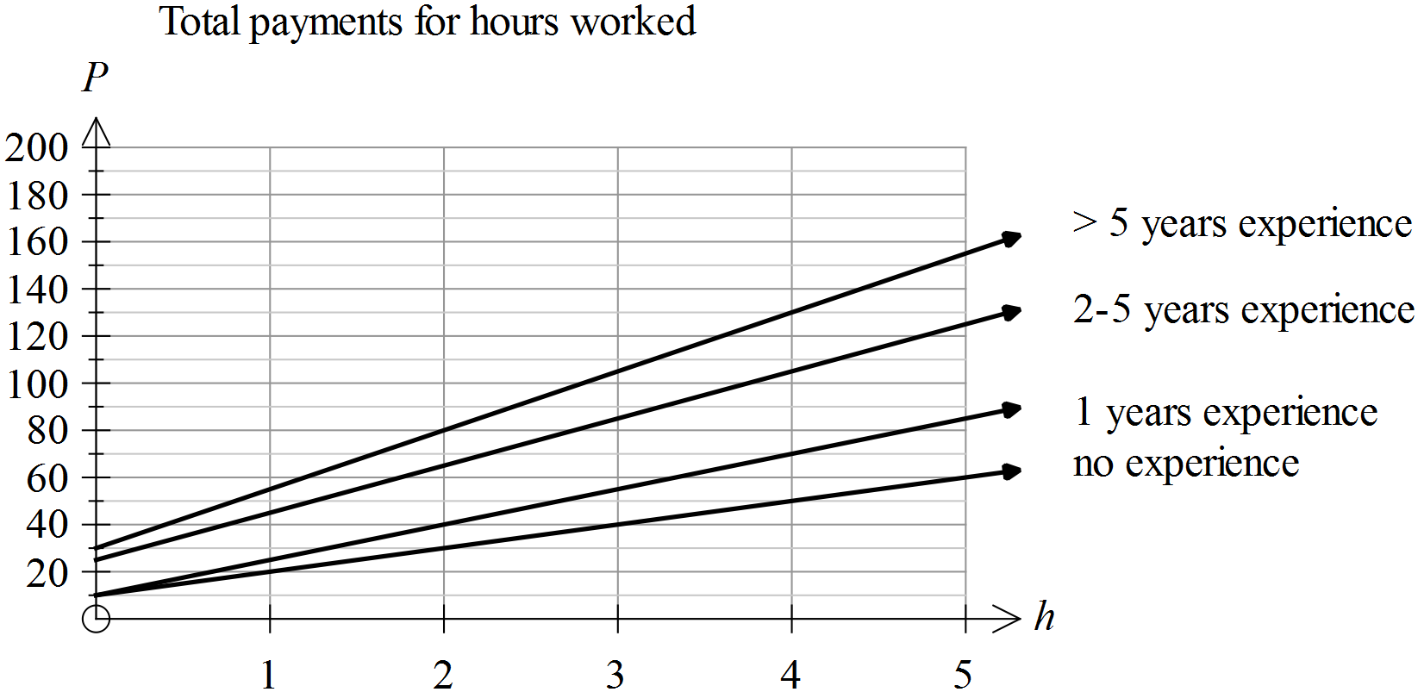

|  |  |
| --- | --- |
| Marking key/mathematical behaviours | Marks |
| * Places correct scale on both axes * Selects appropriate title * Correctly plots *P* when *h* = 5 * Correctly plots petrol allowance * Draws line between points * Labels each graph | 1  1  1  1  1  1  1 |